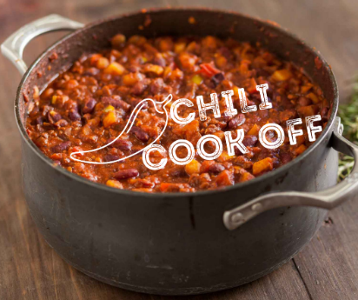
BALD RIDGE MARINA’S
Chili Cook Off & Trunk-or-Treat
SATURDAY, OCT. 22 | 6pm-8pm
REGISTRATION FORM
We’re delighted you are going to cook up your best batch of chili and/or decorate a vehicle! There is no charge to enter, and you may win a prize.
- Chili set up is 5pm on Oct. 22.
- You will need to provide at least a crock pot full of chili.
- If not using a crock pot, you will need to provide your own heating device.
- You may bring any side items you choose that compliments your chili (cornbread, crackers, sour cream, cheese, etc.)
- Bring a large serving spoon. Sample cups, bowls and disposable spoons will be provided.
- Power supplies/outlets are available.
- 1st, 2nd, and 3rd prizes for chili.
- Trunk-or-Treat set up can be earlier than 5pm on Oct. 22 if needed.
- Prizes for top two decorated vehicles
Email the info mentioned below to enter either event or both to Mike Sigmund: mike.sigmund@baldridgemarina.com . ↓
Name
Phone Number
Email Address
Event: Chili / Trunk-or-Treat / Both

