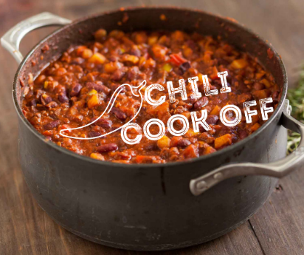
BALD RIDGE MARINA’S
CHILI COOK OFF
SATURDAY, OCT. 23 | 12pm-3pm
REGISTRATION FORM
We’re delighted you are going to cook up your best batch of chili! There is no charge to enter, and you may win a prize.
- Chili set up is 11am on Oct. 23.
- You will need to provide at least a crock pot full of chili.
- If not using a crock pot, you will need to provide your own heating device.
- You may bring any side items you choose that compliments your chili (cornbread, crackers, sour cream, cheese, etc.)
- Bring a large serving spoon. Sample cups, bowls and disposable spoons will be provided.
- Power supplies/outlets are available.
- Category winners are “Best Overall Chili”, “Hottest Chili”, and “People’s Choice Chili”
Fill out the simple form on this page and email it to Beth Kendrick – beth.kendrick@marinemax.com . ↓
Name Click or tap here to enter text.
Phone Number Click or tap here to enter text.
Email Address Click or tap here to enter text.
Do you need a table? Yes ☐ No ☐

